**JAVA EXERCISE**

**Q1.** Write a Java program that reads a string from the keyboard, and outputs the string twice in a row, first all uppercase and next all lowercase. For instance, if user enters “Java", then the output will be “JAVAjava".

**Q2.** Create a super class called **Vehicle**. The **Vehicle** class has the following fields and methods.

* int speed;
* double price;
* String color;
* double getSalePrice();

**Q3.** Create a sub class of **Vehicle** class and name it as **Car**. The **Car** class has the following fields and methods.

* int weight;
* double getSalePrice();

**Q4.** A High School application has two classes: the **Person** superclass and the **Student** subclass. Using inheritance, create two new classes, **Teacher** and **CollegeStudent**. A **Teacher** will be like **Person** but will have additional properties such as *salary* (the amount the teacher earns) and *subject* (e.g. “Computer Science”, “Chemistry”, “English”, “Other”).

The **CollegeStudent** class will extend the **Student** class by adding a *year* (current level in college) nd *major* (e.g. “Electrical Engineering”, “Communications”, “Undeclared”).

The inheritance hierarchy would appear as follows:

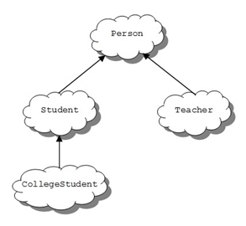

**1**. Write a Teacher class that extends the parent class Person.

**a.** Add instance variables to the class for *subject* (e.g. “Computer Science”, “Chemistry”,, “English”, “Other”) and *salary* (the teachers annual salary). *Subject* should be of type String and *salary* of type double. Choose appropriate names for the instance variables.

**b.** Write a constructor for the Teacher class. The constructor will use five parameters to initialize myName, myAge, myGender, *subject*, and *salary*.  Use the super reference to use the constructor in the Person superclass to initialize the inherited values.